Chapter 1: NPCYF Introduction

1.1 Introduction

1.1.1 About NPCYF
Purpose and Vision
The National Platform for Crop Yield Forecasting (NPCYF) is a comprehensive, web-based digital platform developed to support accurate and efficient forecasting of crop yields across India. Built under the FASAL 2.0 initiative of the Department of Agriculture and Farmers' Welfare (DA&FW), NPCYF represents a significant advancement in agricultural intelligence and decision-making capabilities.
Vision Statement:
To establish a robust, AI-powered national infrastructure that enables stakeholders across the agricultural value chain to access timely, accurate, and actionable crop yield forecasts, thereby contributing to food security, agricultural planning, and policy formulation.
Development Partnership
NPCYF has been developed by IDEAS-Institute of Data Engineering, Analytics and Science Foundation, the Technology Innovation Hub (TIH) at the Indian Statistical Institute (ISI), Kolkata. IDEAS-TIH brings together:
- Deep statistical and mathematical expertise from ISI's legacy
- Advanced capabilities in data science, machine learning, and AI
- Experience in building robust, scalable data platforms
- Understanding of agricultural domain requirements and constraints

1.1.2 Key Features
NPCYF is a comprehensive platform that supports the entire data-to-decision workflow:
1. Multi-Source Data Integration
- Seamless ingestion from diverse data sources (meteorological, hydrological, socio-economic, satellite imagery)
- Support for structured and unstructured data formats
- Automated data quality assessment and validation
2. Advanced Analytics and Modeling
- Statistical and econometric models (ARIMAX, panel models, regularized regression)
- Machine learning algorithms (Random Forest, XGBoost, SVM)
- Deep learning architectures (CNN, RNN, LSTM)
- Ensemble methods for optimal forecast accuracy
3. Feature Engineering Framework
- Comprehensive feature registry with version control
- Automated feature calculation and transformation
- Feature importance analysis and selection
- Reusable feature sets across multiple models
4. Model Management
- Centralized model registry
- Hyperparameter tuning and optimization
- Model versioning and comparison
- Performance tracking and evaluation metrics
5. Forecasting Engine
- Multiple forecasting techniques (point, probabilistic, ensemble)
- Exogenous variable estimation for future periods
- Batch processing for large-scale forecasts
- Confidence intervals and uncertainty quantification
6. Platform Administration
- Role-based access control
- User and project management
- Master data management
- Audit trails and system logging
7. AI-Powered CoPilot
- Natural language interface for queries
- Intelligent assistance for data operations
- Automated model recommendations
- Insight generation and interpretation

1.2 Home Page

1.2.1 Platform Overview
After successful login, users are presented with the Home Page, which serves as the central information hub for the NPCYF platform.
The home page features a clean, organized layout with:
- Header Section: Platform branding with NPCYF logo and organizational information
- Institutional Partners: Logos of IDEAS-TIH, ISI, National Mission on ICPS, DST, and Ministry of Agriculture
- Three Main Information Sections: What's New, Quick Glance, and About NPCYF
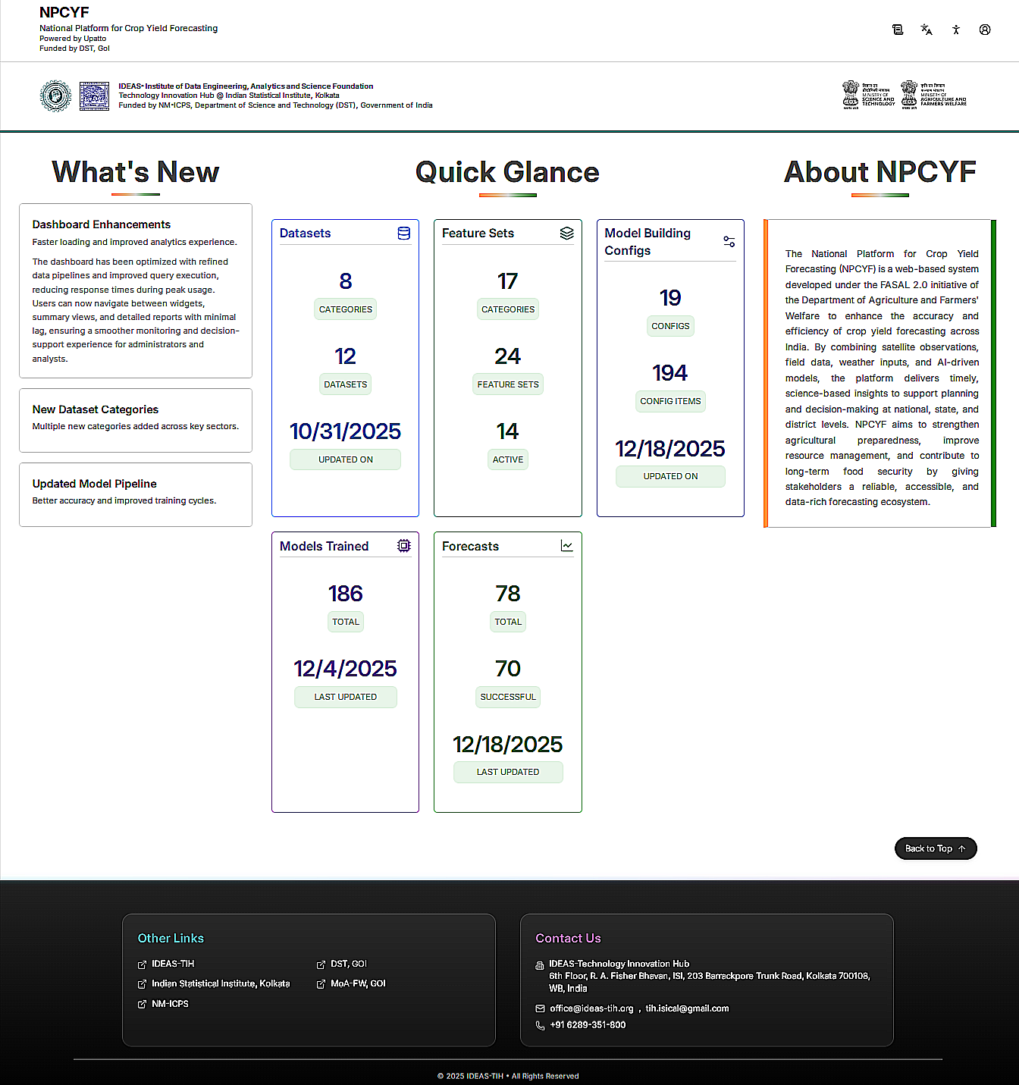

1.2.2 Key Information Sections
The Home Page is organized into several informational sections that provide users with a quick overview of platform capabilities and statistics:
What's New
The What’s New section highlights recent enhancements and functional updates introduced on the platform. It communicates improvements aimed at optimizing performance, expanding data coverage, and strengthening analytical workflows.
Recent dashboard enhancements focus on improving system responsiveness and analytical usability. Backend data pipelines and query execution mechanisms have been refined to ensure smoother navigation across dashboards, widgets, and reports, even during periods of high usage. These improvements enable administrators and analysts to monitor datasets, models, and forecasts with minimal delay.
The platform has also introduced new dataset categories across multiple agricultural and environmental domains. These additions broaden the scope of analysis by incorporating diverse inputs such as crop yield data, weather indicators, and related variables, thereby supporting more comprehensive modeling and forecasting.
In addition, the model development pipeline has been updated to improve forecast accuracy and streamline training workflows. These updates help reduce model development time while enhancing the reliability and quality of forecasting outputs generated by the platform.
This section highlights recent platform updates and improvements:
Dashboard Enhancements
- Faster loading and improved analytics experience
- The dashboard has been optimized with refined data pipelines and improved query execution, reducing response times during peak usage
- Users can now navigate between widgets, summary views, and detailed reports with minimal lag, ensuring a smoother monitoring and decision-support experience for administrators and analysts
New Dataset Categories
- Multiple new categories added across key sectors, expanding the platform's data coverage and analytical capabilities
Updated Model Pipeline
- Better accuracy and improved training cycles
- Enhanced forecast quality and reduced model development time
Quick Glance
This section provides at-a-glance statistics about platform resources:
Datasets:
- Categories: Organized dataset classifications like APY,Rainfall,Temperature,soil moisture,vegetation index etc
- Datasets: Total number of datasets available
Feature Sets:
- Categories: Feature classification groups
- Feature Sets: Total curated feature collections
- Active: Currently enabled feature sets
Model Building Configs:
- Configs: Model configuration templates like ARIMA,EXO_ARIMAX,RANDOM FOREST etc
- Config Items: Total configuration parameters
Models Trained:
- Total: Total number of models trained on the platform
- This metric indicates the cumulative machine learning and statistical models developed for crop yield forecasting
Forecasts:
- Total: Total forecasts generated
- Successful: Successfully completed forecasts
- This section tracks the number of forecast batches executed and their success rate, providing transparency into forecasting operations
About NPCYF
A comprehensive description of the platform:
"The National Platform for Crop Yield Forecasting (NPCYF) is a web-based system developed under the FASAL 2.0 initiative of the Department of Agriculture and Farmers' Welfare to enhance the accuracy and efficiency of crop yield forecasting across India. By combining satellite observations, field data, weather inputs, and AI-driven models, the platform delivers timely, science-based insights to support planning and decision-making at national, state, and district levels. NPCYF aims to strengthen agricultural preparedness, improve resource management, and contribute to long-term food security by giving stakeholders a reliable, accessible, and data-rich forecasting ecosystem."
Other Links
Quick access to related organizations and resources:
- IDEAS-TIH: Technology Innovation Hub at Indian Statistical Institute
- Indian Statistical Institute, Kolkata: Partner institution
- NM-ICPS: National Mission on Interdisciplinary Cyber-Physical Systems
- DST, GOI: Department of Science and Technology, Government of India
- MoA-FW, GOI: Ministry of Agriculture and Farmers Welfare, Government of India
Contact Us
Platform support and contact information:
IDEAS-Technology Innovation Hub
- Address: 6th Floor, R. A. Fisher Bhavan, ISI, 203 Barrackpore Trunk Road, Kolkata 700108, WB, India
- Email: office@ideas-tih.org, tih.isical@gmail.com
- Phone: +91 6289-351-800
Copyright: © 2025 IDEAS-TIH • All Rights Reserved

1.3. Accessing the Platform

1.3.1 Login Page
The NPCYF login page provides secure access to the platform for authorized users.
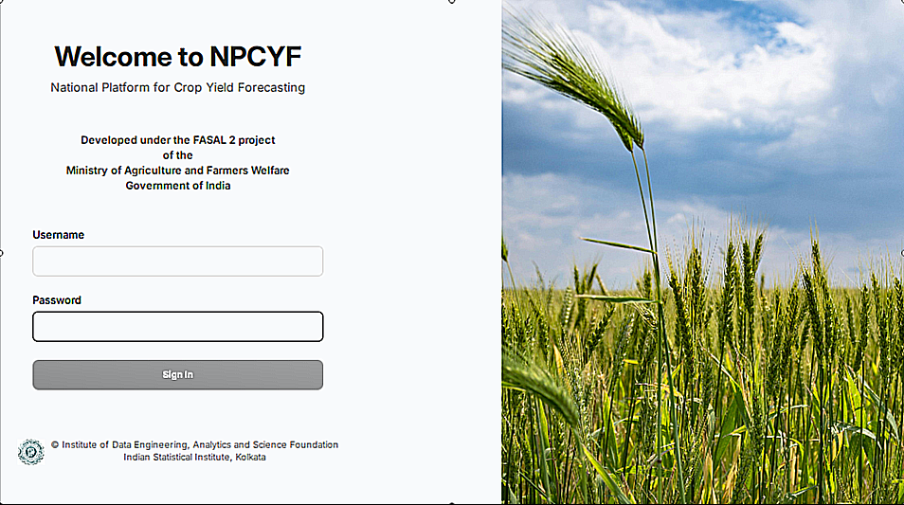
Login Page Components:
The login screen displays:
- Platform Branding: "Welcome to NPCYF" - National Platform for Crop Yield Forecasting
- Project Information: Developed under the FASAL 2 project of the Ministry of Agriculture and Farmers Welfare, Government of India
- Username Field: Enter your registered email address or username
- Password Field: Enter your secure password
- Sign In Button: Click to authenticate and access the platform
- Footer Information:
  - © Institute of Data Engineering, Analytics and Science Foundation
  - Indian Statistical Institute, Kolkata
- Visual Design: Clean, professional interface with agricultural imagery (wheat field) representing the platform's agricultural focus

1.3.2 Authentication Process
Step 1: Navigate to Login Page
- Open your web browser
- Enter the NPCYF platform URL provided by your administrator
- The login page will be displayed
Step 2: Enter Credentials
- Enter your registered username/email address in the "Username" field
- Enter your password in the "Password" field
- Note: Password entry is case-sensitive
Step 3: Access Platform
- Click the "Sign In" button
- Upon successful authentication, you will be redirected to the home screen
- Your session will remain active for a configured duration
First-Time Login:
When logging in for the first time, you may be required to:
- Change the temporary password provided by the administrator
- Complete your user profile
- Review and accept platform terms and conditions

1.4. Dashboard Overview
The Dashboard page provides structured access to all platform modules and functionalities through organized cards grouped by operational area.
The dashboard is organized into five main sections:

1.4.1 Data Management
The Data Management section provides tools for managing datasets, ingesting data, and generating reports.
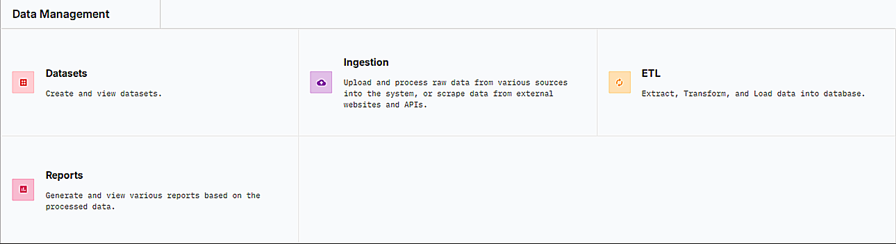

1.4.1.1 Datasets
- Description: Create and view datasets
- Purpose: Manage dataset definitions, metadata, and configurations

1.4.1.2 Ingestion
- Description: Upload and process raw data from various sources into the system, or scrape data from external websites and APIs
- Purpose: Configure and execute data ingestion pipelines

1.4.1.3 ETL (Extract, Transform, Load)
- Description: Extract and Load data into database
- Purpose: Process raw data, apply transformations, and load into the platform's database

1.4.1.4 Reports
- Description: Generate and view various reports based on the processed data
- Purpose: Create reports, export data, and share insights

1.4.2 Feature Engineering
The Feature Engineering section enables users to define, create, and manage features for model building.This section also supports dataset-level transformations, dataset merging, and temporal interval configuration to prepare analytically robust training datasets.

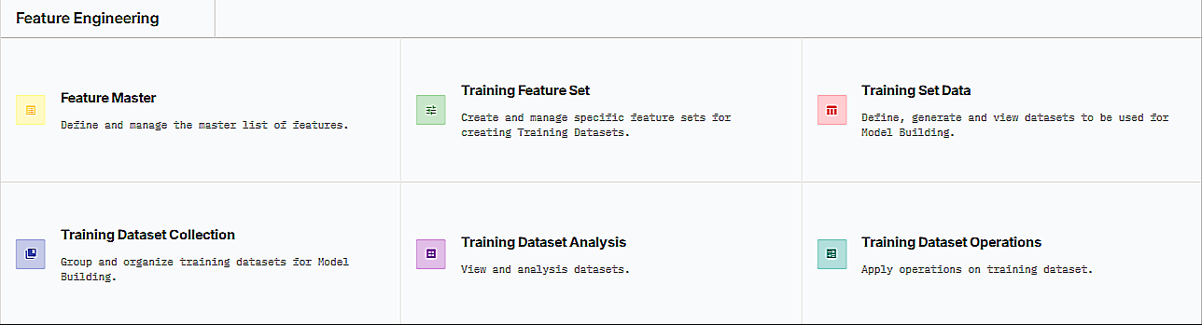

1.4.2.1 Feature Master
- Description: Used to define, manage, and standardize all features (variables) that the platform uses for analysis and model building.
- Purpose: Feature Master provides a centralized way to define and manage feature metadata along with their generation logic, including temporal intervals, aggregations, and location levels. It ensures consistency and reusability of features across datasets, training feature sets, and models, while offering simple controls to add, edit, activate, reset, or delete features from a single interface.

1.4.2.2 Training Feature Set
- Description: A Training Feature Set is a structured collection of selected features, along with their temporal intervals and configurations, prepared specifically for training a model.
- Purpose: It groups relevant features from the Feature Master, defines target variables and time windows, and ensures the right inputs are consistently used for model training, enabling reproducible and model-specific feature preparation.

1.4.2.3 Training Set Data
- Description: Training Set Data is the generated and materialized dataset created by applying a selected training feature set to specific crops, seasons, years, locations, and source collections[the below boxes are etl history].
- Purpose: It converts configured features into ready-to-use training data by generating and materializing datasets, ensuring consistent, reproducible inputs for model training, validation, and analysis.

1.4.2.4 Training Dataset Collection
- Description: A Training Dataset Collection is a logical grouping of multiple training datasets ,of a particular category ,created for a specific modeling or experimentation objective.
- Purpose: It organizes and manages related training datasets under a single collection, making it easier to reuse, compare, and maintain datasets across different models, experiments, and analysis workflows.

1.4.2.5 Training Dataset Analysis
- Description: Training Dataset Analysis is the stage where the generated training datasets are examined using analytical and visualization tools.
- Purpose: It helps analyze what has been trained by evaluating data distributions, trends, and relationships among features and the target variable, enabling validation of data quality and readiness before model training.

1.4.2.6 Training Dataset Operations
- Description: Training Dataset Operations is a module that enables transformation and merging of training datasets
- Purpose: It allows users to clean, reshape, and combine multiple datasets through transformations and joins, helping prepare consistent, analysis-ready datasets while maintaining traceability of all operations before model training.

1.4.3 Model Building
The Model Building section provides tools for defining model configurations, executing batch model training, monitoring execution status, and managing generated model artifacts.
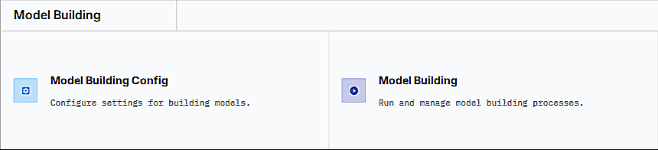

1.4.3.1 Model Building Config
- Description: Model Building Config is a structured setup that defines a unique configuration for model training, combining an algorithm, data split, and hyperparameters into a distinct configuration collection.
- Purpose:It standardizes and manages different model setup combinations, ensuring each algorithm–hyperparameter–data split combination is uniquely tracked, reusable, and reproducible for consistent model training and experimentation.

1.4.3.2 Model Building
- Description: Model Building is the process of executing configured model training batches using selected datasets and model configurations to generate trained models and related artifacts.
- Purpose: It enables systematic execution, monitoring, and management of model training runs, captures run details and statuses, and produces model artifacts and evaluation outputs required for validation, comparison, and deployment.

1.4.4 Forecasting
The Forecasting section enables users to configure forecasting parameters, estimate exogenous variables, define forecast batches, and execute forecasts using trained model artifacts.

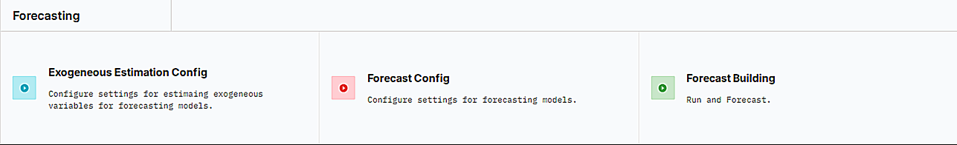

1.4.4.1 Exogeneous Estimation Config
- Description: Exogenous Estimation Config defines configuration collections that specify how exogenous (external) features are estimated or projected for use in forecasting.
- Purpose: It organizes feature-wise estimation methods for future periods, links them with training dataset collections, and ensures consistent, reusable, and transparent generation of exogenous inputs required for forecast models.

1.4.4.2 Forecast Config
- Description:Forecast Config defines the configuration collections that link trained models (artifacts) with target settings such as forecast year and target variable.
- Purpose:It standardizes how forecasts are generated by selecting the appropriate trained model artifacts and target horizon, ensuring consistent, reusable, and well-documented forecast setups.

1.4.4.3 Forecast Building
- Description: Forecast Building is the process of creating and executing forecast batches using predefined forecast configurations and exogenous estimation settings.
- Purpose:It enables controlled execution of forecasting runs, tracks batch runs and results, and produces final forecast outputs for analysis and decision-making.

1.4.5 Admin Management
The Admin Management section provides administrative tools for platform governance and configuration.
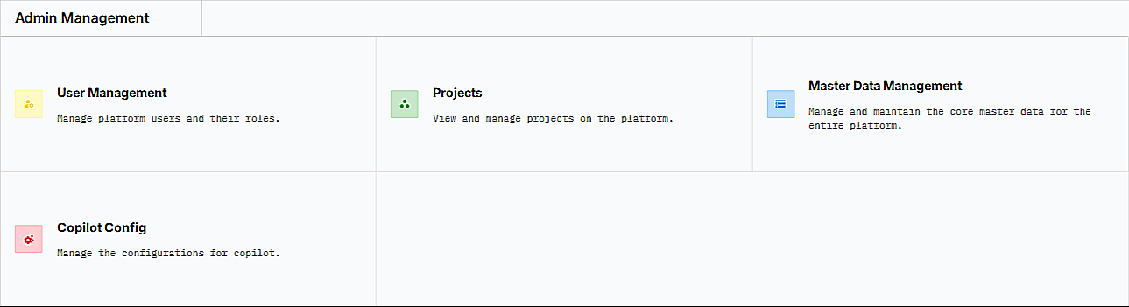

1.4.5.1 User Management
- Description: Manage platform users and their roles
- Purpose: Create user accounts, assign roles, and control access permissions

1.4.5.2 Projects
- Description: View and manage projects on the platform
- Purpose: Create projects, associate users and datasets, and organize work

1.4.5.3 Master Data Management
- Description: Manage and maintain the core master data for the entire platform
- Purpose: Define and update reference data (seasons, crops, states, districts)

1.4.5.4 Copilot Config
- Description: Manage the configurations for copilot
- Purpose: An AI-powered CoPilot chat interface is available across the platform, allowing users to interact using natural language queries and refresh sessions for continued assistance.


Additional Feature: Chat interface - "Hi! How can I help you today?" with a refresh session option for the AI-powered CoPilot assistance.

1.5. User Roles and Responsibilities
NPCYF implements role-based access control (RBAC) to ensure users have appropriate permissions based on their responsibilities.

1.5.1 Role Definitions
1. Super Admin
- Primary Responsibilities: Overall system management, user account creation, role assignment, system configuration, master data management
- Key Permissions: Full access to all platform features including Admin Management, User Management, Project Management, and Master Data Management
2. Project Owner
- Primary Responsibilities: Project oversight and coordination, user management within projects, resource allocation
- Key Permissions: Full access to Project Management functionalities; no access to Admin Management module
3. Data Engineer
- Primary Responsibilities: Configure and manage data sources, monitor data ingestion, data quality management, ETL operations
- Key Permissions: Access to Data Management components (Ingestion, ETL, Datasets) and others but no access to Admin Management

1.6. Important Contacts

Technical Support: - Email: support@npcyf.gov.in - Phone: +91-XXX-XXX-XXXX - Support
Hours: Monday-Friday, 9:00 AM - 6:00 PM IST
Platform Administration: - Email: admin@npcyf.gov.in - For access requests, role changes,
and administrative queries
Training and Onboarding: - Email: training@npcyf.gov.in - For training schedules,
documentation, and learning resources
Feature Requests and Feedback: - Email: feedback@npcyf.gov.in - We welcome your
suggestions for platform improvements
Emergency Contact: - For critical system issues outside business hours - Phone:
+91-XXX-XXX-XXXX (24x7 emergency line)

1.7 Document Information
Document Information: - Version: 1.0 - Last Updated: October 2025 - Prepared By:IDEAS-TIH, Indian Statistical Institute - For: Department of Agriculture and Farmers’Welfare - Classification: Internal Use - Authorized Users Only

